GIS projected coordinates as per Bhulekh-Naksa
Left – Budhia Side | Right-Prasanna Side | Spot Name | Actual | Present
1421.44791, 542.76984 | 1422.67871, 547.55719 | Budhia Start | 16.3 | 11.5
1497.73708, 516.18799 | 1498.85676, 519.12716 | Budhia End (Plot:163) | 10.4
1507.16959, 512.80672 | 1508.21463, 515.73655 | Plot: 165 Start | 10.2
1513.40175, 510.83761 | 1514.42662, 513.38122 | Ajaya Start (Plot:166) | 9.0
1523.06633, 507.75061 | 1524.56899, 509.51450 | Ajaya End (Plot:166) | 7.7 | 8.0
Actual & Present measure in Foot. Inch.

Right-Prasanna side length: 356 ft 10 in
Left-Budhia side length: 352ft 8 in
14+8:22 foot total bari prsana+us

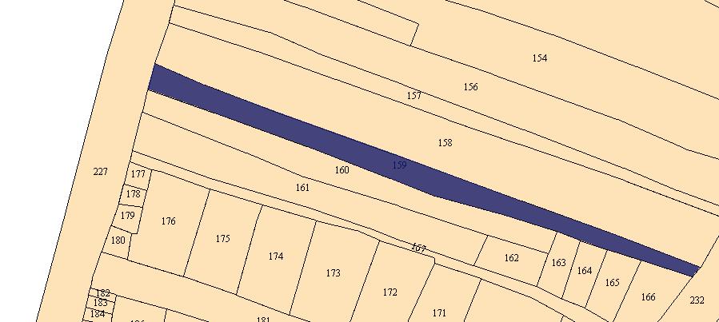

Land survey conversion (Odisha context):
1 chain = 100 kadi (links)
1 chain = 66 feet
Therefore, 1 kadi = 0.66 feet ≈ 7.92 inches
https://bhunaksha.nic.in/bhunaksha/Bhunaksha3.0UserGuide/Bhunaksha3.0UserGuide.pdf

